Title Goes Here --
May Be Two Lines if Needed

First X. Lastname
Title
Organization
City, State/Province, Country
Fax: +1 508 526 8273
E-mail: your.name@domain.xxx
First X. Lastname [ 2nd author if any]
Title
Organization
City, State/Province, Country
Fax: +1 508 526 8273
E-mail: your.name@domain.xxx



Abstract
Duplicate your abstract text here. Break into several paragraphs if appropriate.
Often papers have more or newer information than was available when the abstract was submitted. Some minor editing of the original abstract submission is acceptable, as long as the paper content substantially matches the submission
Please note that papers must not be commercial presentations. While it is unavoidable, or sometimes appropriate, to mention specific products and manufacturers’ names, it should be merely for completeness in describing a solution to a problem, or for documenting what you have done. The main focus of the paper must be the flight inspection product, rather than a commercial broadcast or advertisement.

Introduction
Introductory text should be inserted here. Several paragraphs may be appropriate.
Papers must be submitted in Microsoft Word format (If you have Word 2007, please save your paer in version Office 2003 format for submittal at the IFIS web site.)
Paragraphs should be single-spaced, with double-spacing between paragraphs.
Use full justification for the margins.
Papers should be limited to 10 pages.
Text is entered as 10 point, Times New Roman font.
Page Setup should use 8.5” x 11” paper.
Use standard symbols and abbreviations. Spell out acronyms the first time they are used. Example: The Localizer (LOC) was found out of service, but the Automatic Flight Inspection System (AFIS) was quickly able to define the problem.
If you include formulas, please use black color. Use Microsoft’s equation editor if you can.

FIRST MAJOR HEADING
Example of first major heading: Background & Definitions. Copy the major heading above and insert as many times as appropriate for your outline.
Major headings are typed in all capitol letters, bold, and underlined. They will be followed by one blank line.
Insert paragraphs as needed.

First Minor Heading of Paper
Minor headings are typed using standard title capitalization rules (capitalize only major words), and are bold and underlined. They will be followed by one blank line. Copy the minor heading above and insert as many times as appropriate for your outline.
More paragraph(s)

Second Minor Heading of Paper
There should be two or more minor headings per major heading.
Figures and tables may occupy either one column or two. The following is an example of a larger graphic (figure), spanning two columns. Use continuous section breaks (Insert, Break, Continuous) and column formatting (Format, Columns) to switch between one and two-column formats. Locate table captions above the tables and figure captions below the figures. Place each figure or table and its caption in a separate paragraph, center justified. Headings should be bolded.
Format each figure to appear “in line with text” (Format, Object, Layout, In line with text).

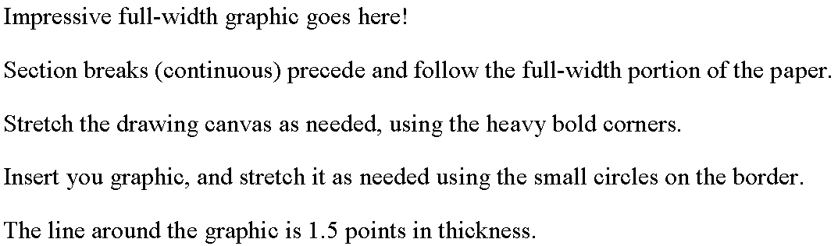
Figure 1. Insert a Caption Here. Capitalize Major Words, but not Connecting Words.

Text continues in 2-column format after the full width section.
Insert more major and minor headings as appropriate.
If you have graphics that occupy only one column, they may be merely inserted after your text stops.

SECOND MAJOR HEADING
A single-column table is illustrated below. It may be best to use a heavier outline for the table, with light lines within the table to separate cells[1]. If a table spans multiple pages or columns, format it to repeat first row at the top of each page/column (Table, Table Properties, Row, Repeat as header row...).¹
Table 1. Aircraft Dimensions Used in Modeling
Aircraft | Tail Height (ft) | Fuselage Length (ft) | Class
B-737 | 36.5 | 109.6 | Medium
B-747 | 63.7 | 231.8 | Large
B-757 | 44.5 | 155.3 | Large
B-767 | 52.0 | 159.2 | Large
B-777 | 60.8 | 209.8 | Large
A-320 | 38.7 | 123.3 | Large
A-330 | 58.7 | 193.8 | Large
A-380 | 84.0 | 239.9 | Large

Insert an empty paragraph following each table. Format the paragraph for zero vertical spacing before or after it (Format, Paragraph, Indents and Spacing, Before/After).
Another paragraph.
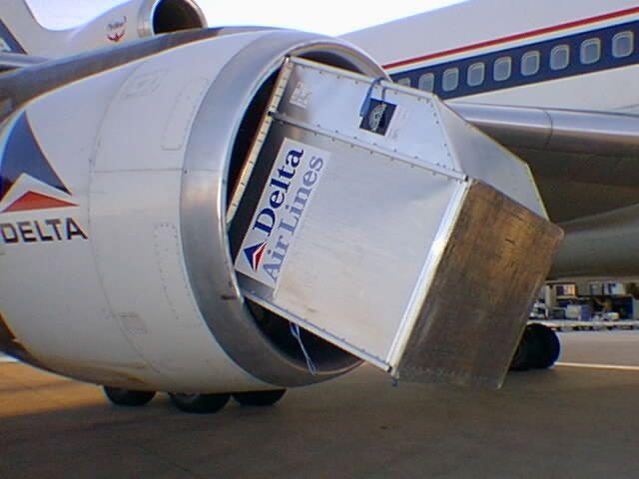
Figure 2. Example Aircraft Model, Side View
Pictures, drawings, and photographs should be black and white for the paper, but may be in color for the presentation. Be sure that each Table and Figure is referenced at least once within the text.

CONCLUSIONS
This text can be used optionally to introduce your conclusions.
a. Insert your conclusions here (if any).
b. This is a second conclusion – there may be many.

RECOMMENDATIONS
The following recommendations are made for the benefit of xxxxxxxxxx (or similar)
Recommendation one.
Recommendation two, etc.

FUTURE WORK
If you wish to discuss any proposed future work, place it here.

ACKNOWLEDGMENTS
If any

REFERENCES
- References should be placed at the end of the paper, like this. To refer to the reference within the body of the document, place a tag such as [1] or a superscript numeral at the end of the relevant phrase or sentence.¹ Examples are shown on page 2 of this template. References should begin with the source company or organization, then the date of publication, an underlined document title, followed by document details. Examples follow.
- ICAO, July 1996, International Standards and Recommended Practices, Annex 10 to the Convention on International Civil Aviation, Volume 1, Radio Navigation Aids, 5th Edition, http://www.icao.int
- FAA, 31 October 1995, Siting Criteria for Instrument Landing Systems, Order 6750.16C

APPENDIX 1
Title of Appendix Here (Example: Excerpts from Annex 10 Guidance Material)

This is an example of an Appendix, normally used for background material, or for quoting a document appropriate for your topic.
Prepare in 2-column format.

